

***INSTITUTE OF INFORMATION TECHNOLOGY***

***JAHANGIRNAGAR UNIVERSITY***

**Number of Lab Report :** 05

**Name of Lab Report :** Johnson counter with D flip-flop.

**Course Tittle :** Digital Logic Design Lab.

**Course Code :** ICT – 2104

**Submission Date :** 02/03/2021

**Submitted To Submitted By**

[Dr. Md. Sazzadur Rahman](https://juniv.edu/teachers/rhemel) Md. Shakil Hossain

Associate Professor Roll – 2023

IIT – JU 2nd year 1st Semester

IIT – JU

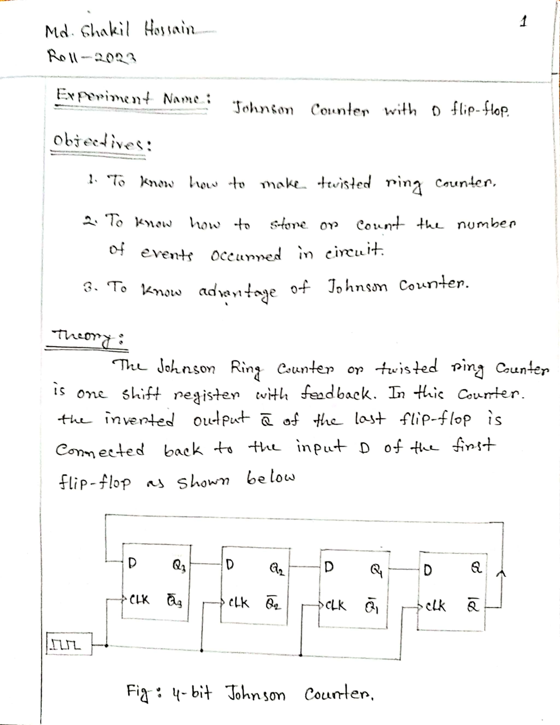

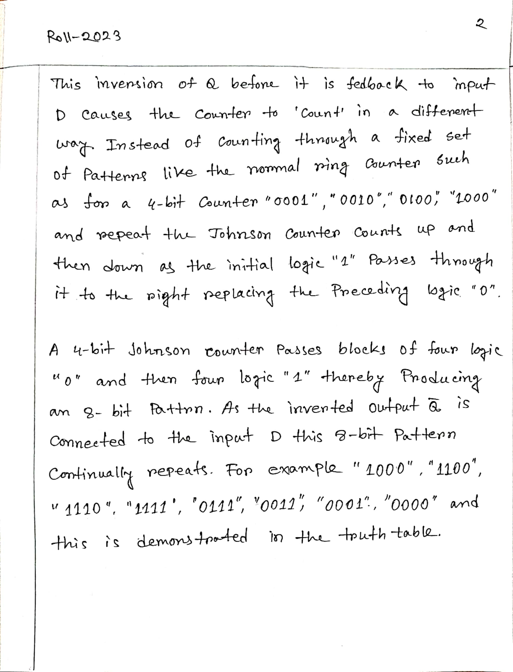

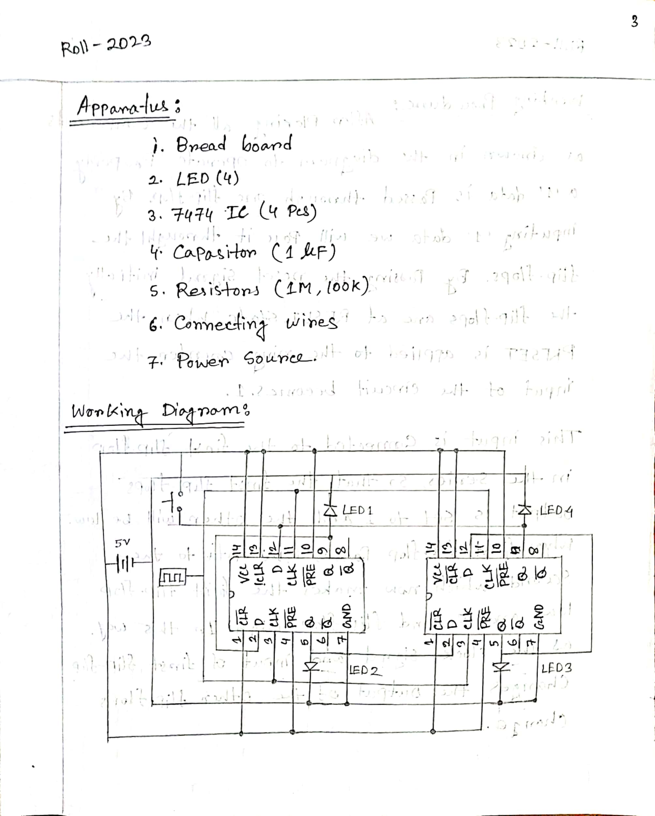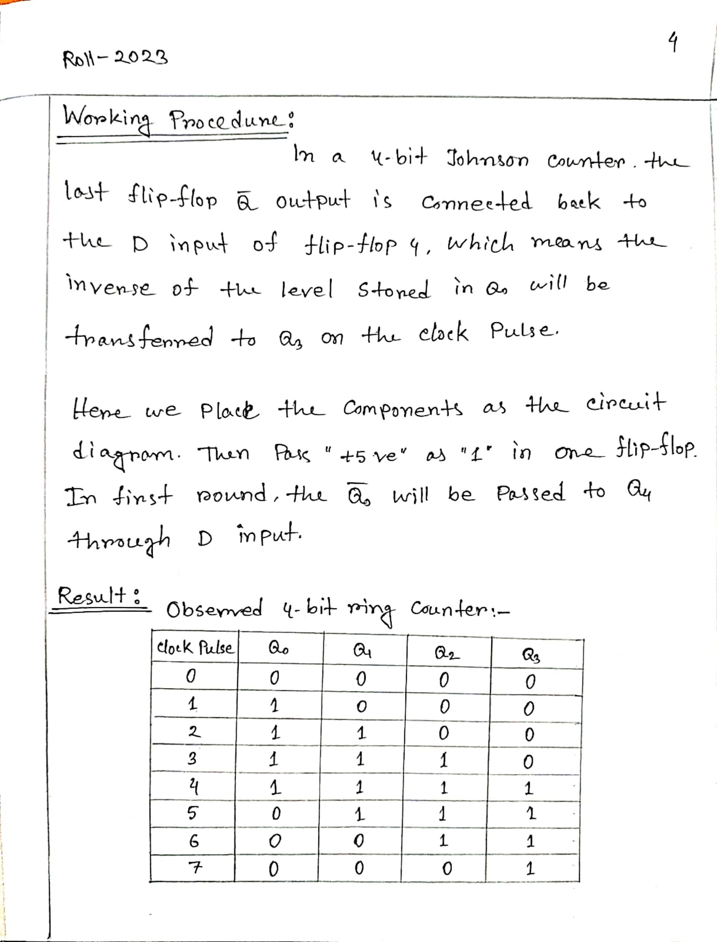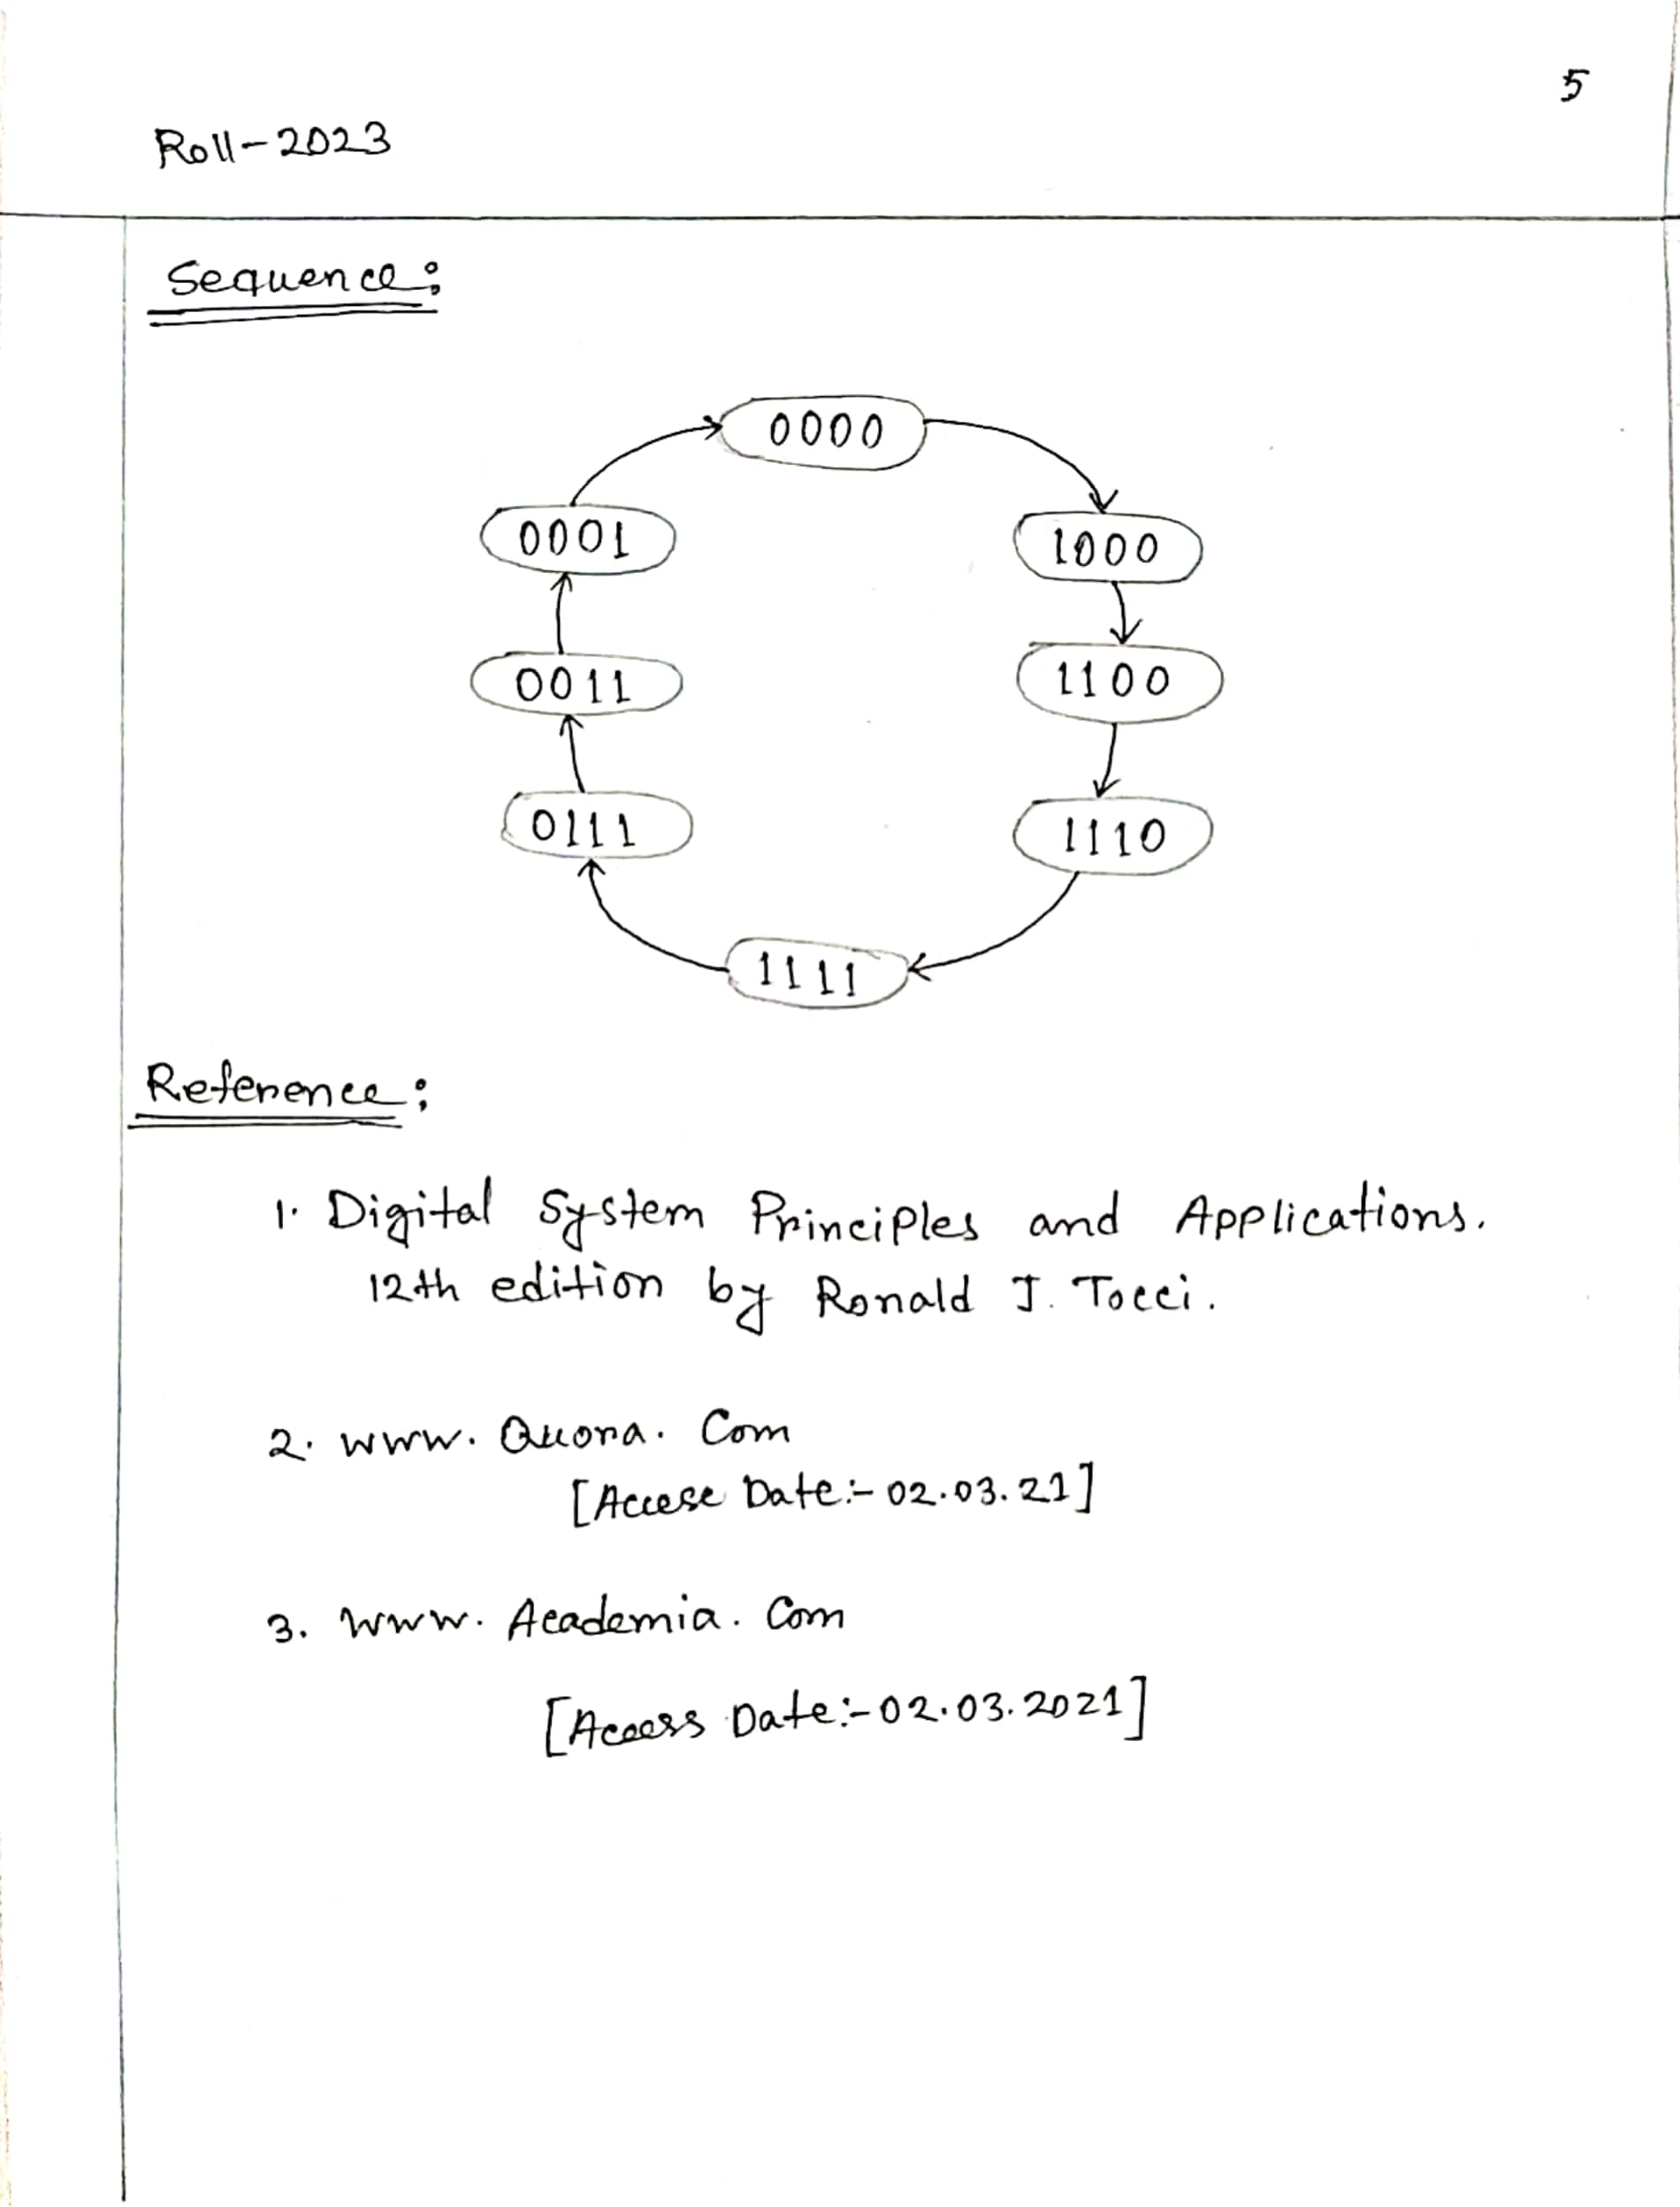

**THE END**